# Registar office Letter header B_W.jpg

# **Automatic LED Emergency Light**

A Project Report

Submitted in the partial fulfillment of the requirements for the award of the degree of

# Bachelor of Technology

# in

Department of Electronics & Communication Engineering

by

2210040003

2210040017

2210040026

2210040089

under the supervision of

# Mrs K Madhavi, Assistant Professor



Department of Electronics & Communication Engineering

K L E F, Off Campus-Hyderabad,

Aziz Nagar- 500075, Rangareddy(Dist), Telangana, India.

August, 2023

**Declaration**

The Project Report entitled “Automatic LED Emergency Light “is a record of bonafide work of 2210040003, 2210040017, 2210040026, 2210040089, submitted in partial fulfillment for the award of B.Tech in Department of Electronics & Communication Engineering to the K L University. The results embodied in this report have not been copied from any other departments/University/Institute.

2210040003 – T A S VARDHAN

**2210040017 – B NAMO SAI REDDY**

2210040026 – B PRITAM

2210040089 – M VISHNU VARDHAN REDDY

**Certificate**

This is to certify that the Project Report entitled “Automatic LED Emergency Light” is being submitted by 2210040003, 2210040017, 2210040026, 2210040089 submitted in partial fulfillment for the award of B.Tech in Department Of Electronics & Communicaton Engineering to the K L University is a record of bonafide work carried out under our guidance and supervision.

The results embodied in this report have not been copied from any other departments/ University/Institute.

## Signature of the Co-Supervisor (If Available) Signature of the Supervisor

Name and Designation Name and Designation

## Signature of the HOD Signature of the External Examiner

**ACKNOWLEDGEMENTS**

It gives us immense pleasure to convey our gratitude to our honorable President, **Er. Koneru Satyanarayana Sir**, for providing us with the opportunity and a well-equipped platform to successfully complete this project-based laboratory report.

We extend our heartfelt appreciation to our Principal, **Dr. A. RAMA KRISHNA Sir**, for his exceptional administrative support, which has significantly contributed to our academic growth.

We would also like to acknowledge our deep appreciation for **Dr. Goutham Makkena Ph.D.,** our Head of the Department (ECE), for his valuable insights and support throughout this endeavor.

We extend our sincere thanks to our esteemed project supervisors, **Mrs. K. Madhavi** and **Dr. Joshitha C**, for their innovative ideas, unwavering encouragement, genuine appreciation, and intellectual guidance. Their mentorship played a pivotal role in inspiring us to navigate this project to success.

Lastly, we take this opportunity to express our gratitude to all those who directly or indirectly contributed to the success of this project report. Your efforts have been instrumental in its accomplishment.

**Yours Sincerely,**

2210040003-T A S Vardhan

**2210040017-B Namo Sai Reddy**

2210040026-B Pritam

2210040089-M Vishnu Vardhan Reddy

**ABSTRACT**

The described circuit functions as an intelligent emergency light system with light-sensitive activation. It comprises several stages that ensure efficient power usage and reliable performance.

The initial phase involves stepping down the input AC voltage using a transformer (9-0-9V) and rectifying it using a 1 Amp bridge rectifier, converting it into DC. An LED connected in tandem with resistor R1 indicates the status of the rectified DC output. To stabilize this DC output, a positive regulator IC 7808 is employed.

The regulated power is then directed to a light-sensing circuit, incorporating a common 5mm LDR (Light Dependent Resistor). This LDR exhibits low resistance under illuminated conditions and high resistance in darkness. The sensitivity of the LDR is adjustable through the 10KΩ variable resistor VR1. The system is calibrated so that the LEDs just illuminate, with the preset maintaining this balance. The LDR, positioned atop the emergency light, ensures that the system operates only when ambient light is insufficient, preventing unwanted activation during daylight or when room lights are on.

Two LEDs are connected in series to conserve energy, with the combined current draw being equivalent to that of a single LED. This arrangement eliminates the need for dropping resistors, enhancing energy efficiency.

In the presence of light, the LDR permits current flow to the base of transistor Q1, causing it to conduct. This, in turn, grounds the gate terminal of the MOSFET, disconnecting the LED array from the DC bias ground supply. Conversely, in the absence of light, the LDR blocks current to the base of Q1, maintaining it in a non-conducting state. As a result, the MOSFET gate remains ungrounded, allowing current to pass between the drain and source terminals, leading to the illumination of the LED array.

During power outages, a 6-volt, 4.5Ah battery serves as the power source for the circuit, ensuring continued functionality. In summary, the circuit employs a light-sensitive mechanism to activate LED lighting, optimizing energy usage and offering reliable emergency illumination through a well-designed sequence of stages.

**Table Of Contents**

|  |  |  |
| --- | --- | --- |
| S.No | Content | Page Number |
| 1. | Introduction | 7 |
| 2. | Literature Review | 9 |
| 3. | Theoretical Analysis | 11 |
| 4. | Design and Implementation | 17 |
| 5. | Experimental Investigations | 22 |
| 6. | Experimental Results | 27 |
| 7. | Discussion of Results | 30 |
| 8. | Summary | 35 |

**Introduction**

The introduction section of the project report lays the foundation for understanding the intelligent

emergency light system with light-sensitive activation. This section provides essential context and

outlines the project's objectives, scope, and significance.

**1.1 Background and Motivation:** The increasing demand for energy-efficient and reliable emergency lighting systems has driven the exploration of novel technologies. Traditional emergency lights often consume excessive energy and lack the ability to adapt to varying lighting conditions. This project aims to address these limitations by introducing an intelligent emergency light system that utilizes light-sensitive activation. By harnessing ambient light levels, the proposed system optimizes energy consumption and enhances overall efficiency, thereby making emergency lighting more sustainable and adaptable. In the ever-evolving landscape of modern energy needs, the demand for energy-efficient and reliable illumination solutions has gained prominence. Conventional lighting systems, particularly those employed in emergency situations, often suffer from inefficiencies that lead to excessive energy consumption and environmental concerns. This backdrop highlights the crucial need for innovative solutions that combine effective lighting with judicious energy utilization.

**1.2 Problem Statement:** Conventional emergency lighting solutions suffer from inefficiency, often resulting in unnecessary power consumption and reduced backup duration during critical situations. Additionally, these systems lack the ability to differentiate between day and night conditions, leading to inadvertent activations. Therefore, there is a need for an innovative emergency lighting solution that intelligently responds to ambient light levels and ensures efficient energy utilization.

Conventional emergency lighting systems are often devoid of adaptability, remaining illuminated irrespective of ambient lighting conditions. This lack of intelligence not only results in unnecessary energy expenditure but also fails to provide optimal lighting during crucial moments. Addressing these issues necessitates the development of an intelligent emergency light system capable of dynamically responding to varying light levels, thus conserving energy and ensuring appropriate illumination.

**1.3 Objective of the Project:** The primary objective of this project is to design and develop an intelligent emergency light system that incorporates a light-sensitive activation mechanism. The system will automatically detect ambient light conditions and activate the emergency lighting only when the surrounding lighting is inadequate. By doing so, the project aims to achieve significant energy savings, increase the lifespan of the lighting components, and provide reliable illumination during power outages.

The central objective of this project is the conception, design, and realization of an intelligent emergency light system driven by light-sensitive activation. This system aims to revolutionize traditional emergency lighting by integrating the capabilities of light-dependent resistors (LDRs) and advanced electronic components. By harnessing these components, the project strives to create an energy-efficient illumination system that activates only when required, thereby prolonging battery life during power disruptions.

**1.4 Scope and Significance:** The scope of this project encompasses the design, implementation, and testing of the intelligent emergency light system. The system will be equipped with components such as a step-down transformer, bridge rectifier, voltage regulator, light-dependent resistors (LDRs), transistors, MOSFETs, and LEDs. The significance of this project lies in its potential to revolutionize the way emergency lighting is managed. By intelligently responding to ambient light conditions, the system ensures that energy is used judiciously, reducing operational costs and contributing to a more sustainable environment.

This project’s scope encompasses a comprehensive journey spanning the conceptualization, design, construction, and empirical testing of the proposed intelligent emergency light system. The integration of key components, including step-down transformers, rectifiers, voltage regulators, LDRs, transistors, and LEDs, forms the cornerstone of the system’s architecture. The significance of this project lies in its potential to foster sustainable energy practices while addressing the need for efficient and dependable emergency lighting solutions across diverse environments.

**1.5 Overview of the Circuit and its Components:** The proposed intelligent emergency light system comprises several critical components. The initial stage employs a step-down transformer (9-0-9V) to reduce input AC voltage, followed by rectification using a 1 Amp bridge rectifier. The rectified DC output is regulated using a positive regulator IC 7808, ensuring stable voltage supply. This regulated power is then directed to a light-sensing circuit, which employs a 5mm light-dependent resistor (LDR). The LDR's behavior allows it to detect changes in ambient light levels and adjust the circuit's activation accordingly. Transistors and MOSFETs are used to control the LED array's illumination based on the LDR's input.

The system is further equipped with a battery backup (6 volts, 4.5Ah) to provide power during mains failure. The envisioned circuit capitalizes on the principles of energy transformation and electronic control to realize its intelligent functionality. A step-down transformer assumes the pivotal role of converting incoming alternating current (AC) voltage to a level suitable for subsequent rectification. The rectified direct current (DC) output is further refined through the implementation of a positive regulator IC 7808, ensuring stable voltage levels.

At the heart of the system lies the light-dependent resistor (LDR), which dynamically modulates the circuit's behavior based on ambient light intensity. The LDR's inherent property of altering its resistance in response to light facilitates its role as a sensitive light sensor. Transistors and metal-oxide-semiconductor field-effect transistors (MOSFETs) operate as intelligent switches, facilitating the activation or deactivation of the LED array based on the LDR's input. This strategic interplay between components guarantees that the emergency light system activates exclusively under low-light conditions, ultimately conserving energy resources while enhancing operational efficacy.

**Circuit Diagram:**

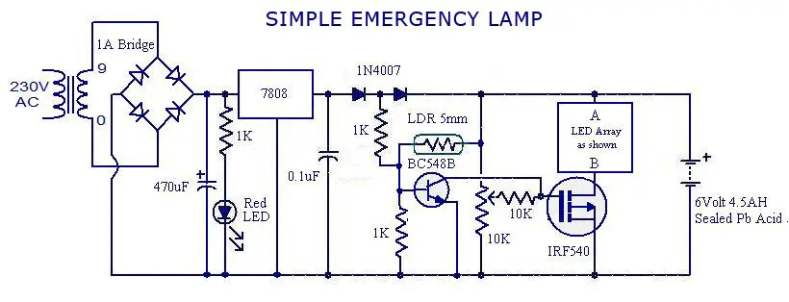

**Literature Review**

**2.1 Study of Existing Emergency Lighting Systems:**

The study of existing emergency lighting systems reveals that traditional designs lack adaptability and energy efficiency. Many systems rely on manual activation or simple timers, which can result in unnecessary energy consumption. By exploring the limitations of these conventional systems, it becomes evident that a more intelligent approach is needed to optimize energy usage and provide reliable illumination during emergencies. Emergency lighting systems play a crucial role in ensuring safety during power outages or critical situations. Conventional systems often employ manual switches or simple timers, leading to energy wastage or inadequate illumination. Modern solutions aim to enhance efficiency and responsiveness. Various methods, such as motion detection, occupancy sensing, and light-sensitive activation, have been explored to optimize energy usage and ensure timely illumination when needed.

**2.2 Light-Sensitive Activation Mechanisms:**

Light-sensitive activation mechanisms are crucial for the proposed intelligent emergency light system. These mechanisms utilize light-dependent resistors (LDRs) to detect changes in ambient light levels. The behavior of LDRs is based on their resistance variation with light intensity. Understanding these mechanisms is essential for designing a system that can intelligently respond to lighting conditions, ensuring that emergency lighting is only activated when necessary.

Light - sensitive activation is an innovative approach in emergency lighting. This mechanism utilizes Light Dependent Resistors (LDRs), which exhibit a varying resistance based on ambient light levels. In well-lit conditions, LDRs offer low resistance, while in darkness, they present high resistance. This behavior allows the system to activate the emergency lighting only when the ambient light falls below a certain threshold, ensuring energy-efficient operation.

**2.3 Components: Transformers, Rectifiers, Regulators, LDRs, Transistors, MOSFETs, LEDs:**

The successful implementation of the intelligent emergency light system relies on the understanding of various components. A step-down transformer is essential for voltage reduction, followed by a bridge rectifier for AC-to-DC conversion. Voltage regulation is achieved using a positive regulator IC 7808, while light-sensing involves the utilization of LDRs. Transistors and MOSFETs play a pivotal role in controlling LED illumination based on the LDR's input. LEDs are energy-efficient light sources chosen for their long lifespan and low power consumption.

**Transformers:** Transformers are vital in electrical systems for voltage transformation. In this project, the step-down transformer converts higher AC voltage to a lower one (9-0-9V), suitable for subsequent stages. The transformer ensures safety and compatibility with electronic components.

**Rectifiers:** A bridge rectifier is employed to convert the AC voltage from the transformer into DC. It uses diodes to rectify the alternating current, resulting in a unidirectional flow of current. The rectification process ensures a steady DC output for the circuit.

**Regulators:** The IC 7808 positive regulator is a critical component for maintaining a consistent DC output voltage despite variations in input voltage or load. It ensures that the voltage supplied to subsequent stages is within the required range, contributing to stable operation.

**LDRs (Light Dependent Resistors):** LDRs are semiconductors whose resistance changes with light intensity. They are central to the light-sensitive activation mechanism. When exposed to light, LDRs have low resistance, allowing current flow. Conversely, in the absence of light, their resistance increases, limiting current flow. This property enables the system to respond to changing lighting conditions.

**Transistors and MOSFETs:** Transistors and MOSFETs serve as electronic switches. Transistor Q1 is controlled by the LDR's resistance. In the presence of light, Q1 conducts, grounding the gate of the MOSFET. This prevents LED activation. In darkness, Q1 remains off, allowing the MOSFET to be biased and illuminating the LEDs.

**LEDs (Light Emitting Diodes):** LEDs are energy-efficient light sources. Two LEDs are connected in series to save energy, emitting light when current passes through them. The MOSFET's behavior determines whether the LEDs are on or off based on lighting conditions.

**2.4 Energy Efficiency in Lighting Systems:**

Energy efficiency is a critical consideration in modern lighting systems. Traditional emergency lights often waste energy due to continuous operation, even when adequate ambient lighting is available. The proposed intelligent system addresses this inefficiency by activating the emergency lighting only when ambient lighting falls below a certain threshold. By doing so, energy consumption is minimized, and the overall efficiency of the system is significantly improved, contributing to cost savings and reduced environmental impact.

This literature review section provides an in-depth exploration of various aspects related to the project, including existing emergency lighting systems, the importance of light-sensitive activation mechanisms, the significance of different components, and the role of energy efficiency in lighting systems. By examining these factors, the project gains a solid foundation for the design and development of an innovative intelligent emergency light system.

Energy efficiency is a critical consideration in emergency lighting systems. By employing light-sensitive activation and efficient components like LEDs, the system ensures that lighting is activated only when necessary. This reduces energy consumption, prolongs battery life, and contributes to sustainability.

**Theoretical Analysis**

**3.1 Working Principle of a Step-Down Transformer**

A step-down transformer is a fundamental component in electrical systems, serving a critical role in voltage conversion. It plays a pivotal role in this intelligent emergency light system, facilitating the transition from higher AC voltage to a lower, more manageable level.

The underlying principle of a transformer is electromagnetic induction, a phenomenon discovered by Michael Faraday in the early 19th century. It revolutionized the field of electrical engineering and became the cornerstone of many modern technologies, including power transmission and distribution systems.

**Electromagnetic Induction:** Electromagnetic induction occurs when a changing magnetic field induces an electromotive force (EMF) or voltage in a conductor. Transformers harness this principle to transfer energy between circuits by means of magnetic coupling.

**Transformer Construction:** A typical transformer consists of two coils of wire, known as the primary and secondary coils. These coils are wound around a common core made of ferromagnetic material, such as iron. The primary coil is connected to the input voltage source, while the secondary coil provides the output voltage.

**Step-Down Transformer Operation:** In a step-down transformer, the primary coil has more turns than the secondary coil. When an alternating current flows through the primary coil, it generates a magnetic field around the core. This changing magnetic field induces a voltage in the secondary coil according to Faraday's law of electromagnetic induction.

The key principle here is that the ratio of the number of turns in the primary coil to the number of turns in the secondary coil determines the voltage transformation. In a step-down transformer, since the primary coil has more turns, the induced voltage in the secondary coil will be lower than the input voltage.

**Voltage and Current Relationship:** According to the law of conservation of energy, the power in the primary coil is approximately equal to the power in the secondary coil, minus losses due to factors like resistance and magnetic hysteresis in the core. This relationship between voltage and current in the primary and secondary coils is governed by the formula:

V₁ x I₁ ≈ V₂ x I₂

Where:

* V₁ and I₁ are the voltage and current in the primary coil
* V₂ and I₂ are the voltage and current in the secondary coil

**Application in the Emergency Light System:** In the intelligent emergency light system, the step-down transformer's role is pivotal. It converts the higher voltage from the power source to a lower voltage suitable for the subsequent stages of the circuit. This conversion enhances safety, reduces stress on components, and ensures compatibility with the rest of the system.

In summary, the working principle of a step-down transformer revolves around electromagnetic induction. It is a vital component in various electrical systems, including the intelligent emergency light system, where it facilitates voltage transformation while adhering to the principles of energy conservation and electromagnetic induction. By efficiently converting voltage levels, the transformer enables the system to operate optimally and contribute to the seamless functioning of the entire circuit.

**3.2 Bridge Rectifier Operation**

A bridge rectifier is a crucial component in the realm of electronics, serving as an essential means of converting alternating current (AC) into direct current (DC). In the context of the intelligent emergency light system with light-sensitive activation, understanding the operation of a bridge rectifier is paramount for comprehending the flow of electricity within the circuit. This section delves into the intricate details of bridge rectifier operation, shedding light on its fundamental principles and significance within the broader framework of the project.

At the heart of bridge rectification lies the rectifier bridge, commonly known as a diode bridge or full-wave bridge rectifier. The bridge is constructed using a network of diodes interconnected in a specific pattern, forming a bridge-like structure. The arrangement allows for the conversion of the alternating polarity of the input AC voltage into a unidirectional flow of current through the load, resulting in a smooth DC output.

The operation of the bridge rectifier can be elucidated through a comprehensive breakdown of its working:

**3.2.1 Diode Action:** Diodes are semiconductor devices that allow current to flow in one direction while blocking it in the opposite direction. In the bridge rectifier, four diodes are connected in a diamond shape, forming two arms. The input AC voltage is applied across the upper and lower arms of the bridge.

**3.2.2 Half-Cycle Operation:** Consider the positive half-cycle of the AC input voltage. During this interval, the top terminal of the input is positive, while the bottom terminal is negative. Diodes D1 and D3, situated in the upper arm of the bridge, are forward-biased as their anodes are at a higher potential than their cathodes. This enables current to flow through the load in the direction indicated by the arrow, yielding a positive output.

**3.2.3 Reverse-Biasing of Diodes:** During the positive half-cycle, diodes D2 and D4 in the lower arm of the bridge are reverse-biased. They prevent any current from flowing through them, ensuring that the circuit remains open.

**3.2.4 Negative Half-Cycle:** As the input AC voltage transitions into the negative half-cycle, the polarities of the top and bottom terminals switch. Diodes D2 and D4 in the lower arm now become forward-biased, while diodes D1 and D3 become reverse-biased. The current now flows through the load in the opposite direction, maintaining a positive output.

**3.2.5 Smoothing Effect:** The alternating output created by the bridge rectifier consists of a series of positive and negative pulses. To achieve a smoother DC output, a filtering capacitor is often connected across the load. This capacitor charges during the periods of positive half-cycles and discharges during the negative half-cycles, mitigating the fluctuations and producing a more continuous DC output.

The bridge rectifier's ability to efficiently convert AC to DC while maintaining a unidirectional current flow is instrumental in various applications, including power supplies, battery charging, and, in the case of your project, illuminating LEDs during emergency lighting situations. Its robust and reliable operation contributes to the overall functionality and performance of the intelligent emergency light system.

In conclusion, the bridge rectifier serves as a pivotal component in the conversion of AC to DC in the intelligent emergency light system. Its intricate diode arrangement and operation during different half-cycles of the input AC voltage enable the production of a smooth DC output, crucial for ensuring the proper functioning of the circuit. The bridge rectifier's role highlights the synergy between theoretical principles and practical applications, underscoring its significance in modern electronics.

**3.3 Voltage Regulation using IC 7808**

Voltage regulation is a fundamental aspect of electronic circuits, ensuring that a stable and consistent voltage is supplied to various components. In the context of the intelligent emergency light system, the IC 7808 plays a pivotal role in maintaining a regulated output voltage.

The IC 7808, a member of the 78xx series of voltage regulators, is designed to provide a fixed positive output voltage of +8V. This regulator is classified as a linear voltage regulator, which means it achieves voltage regulation by dissipating excess energy as heat.

The voltage regulation process begins with the unregulated DC voltage that is obtained from the bridge rectifier. This voltage may exhibit fluctuations due to variations in input AC voltage, load changes, and other factors. The purpose of the IC 7808 is to counteract these variations and ensure a steady +8V output.

Internally, the IC 7808 comprises various components, including a reference voltage, a voltage divider network, and a pass transistor. The reference voltage is a precise voltage source against which the output voltage is compared. Any deviation from the desired output voltage causes the regulator to take corrective measures.

The voltage divider network plays a crucial role in feedback control. It samples a fraction of the output voltage and compares it to the reference voltage. This comparison generates an error signal that determines the difference between the actual and desired voltages. Based on this error signal, the regulator adjusts the pass transistor to either increase or decrease the output voltage.

When the output voltage is below the desired +8V, the error signal prompts the pass transistor to conduct more current. This allows more current to flow from the input to the output, increasing the output voltage. Conversely, if the output voltage exceeds +8V, the error signal reduces the current flow through the pass transistor, thereby lowering the output voltage.

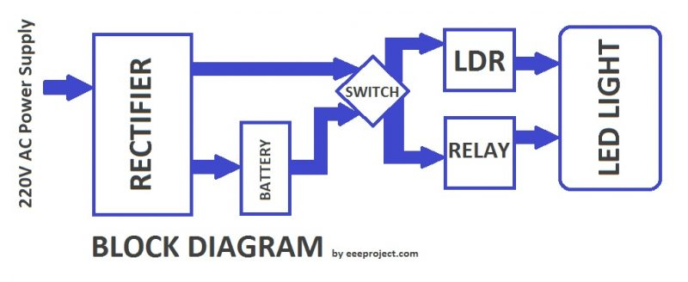

**3.4 Light Dependent Resistors (LDRs) and Their Behavior**

Light Dependent Resistors (LDRs), also known as photoresistors or photocells, are semiconductors that exhibit a significant change in resistance in response to varying levels of incident light. This property makes them essential components in numerous applications, including light-sensing systems like the intelligent emergency light system described in this project.

**3.4.1 Operating Principle:**

The behavior of LDRs is rooted in the intrinsic properties of the semiconductor material from which they are manufactured. These materials contain semiconductor particles that generate free electrons upon absorbing photons (light particles). As the intensity of incident light increases, more photons are absorbed, leading to the creation of a larger number of free electrons. This phenomenon causes a decrease in the resistance of the LDR.

Conversely, when the ambient light diminishes, fewer photons are available to release free electrons. Consequently, the number of free electrons generated decreases, resulting in an increase in resistance. This characteristic can be harnessed in applications where the goal is to detect changes in light levels.

**3.4.2 Behavioral Characteristics:**

The behavior of LDRs is characterized by their spectral response, resistance range, and response time. Spectral response refers to the specific wavelengths of light that the LDR is sensitive to. Resistance range indicates the ratio of resistance values between light and dark conditions. Response time pertains to the time it takes for the resistance to change after exposure to varying light conditions.

In practical terms, LDRs typically have high resistance in the range of several megaohms in the absence of light. As light intensity increases, their resistance can drop to a few hundred ohms. This wide range of resistance change makes LDRs ideal for light-sensing applications.

**3.4.3 Applications:**

LDRs find extensive use in various fields due to their light-sensitive behavior. They are integral components in streetlights, solar panels, camera exposure control systems, and, of course, light-sensitive activation mechanisms in emergency lighting systems.

**3.4.4 Integration in the Project:**

In the intelligent emergency light system described in this project, the LDR plays a critical role in determining the ambient light level. When there is sufficient ambient light, the LDR exhibits low resistance, allowing current to flow through a controlling transistor. This transistor then turns off the MOSFET, preventing the LED array from illuminating.

Conversely, in low-light or dark conditions, the resistance of the LDR increases significantly. This results in minimal current flowing through the controlling transistor, keeping it in the off state. As a consequence, the MOSFET turns on, allowing current to pass through the LED array, providing emergency lighting.

**3.4.5 Conclusion:**

Light Dependent Resistors are versatile components that utilize semiconductor physics to offer a convenient and effective way of detecting changes in light intensity. Their behavior aligns perfectly with the goal of energy-efficient lighting control systems, as demonstrated by their application in the intelligent emergency light system. Understanding the principles behind LDR behavior is crucial for creating responsive and reliable light-sensing systems.

**3.5 Transistor and MOSFET Basics**

Theoretical analysis plays a pivotal role in understanding the intricate workings of electronic circuits. In the context of the intelligent emergency light system with light-sensitive activation, comprehending the fundamentals of transistors and MOSFETs is essential.

**3.5.1 Transistor Basics:**

Transistors are semiconductor devices that enable amplification and switching of electronic signals. They serve as fundamental building blocks in various electronic circuits, contributing to signal processing and control mechanisms.

The most commonly used type of transistor is the Bipolar Junction Transistor (BJT). It comprises three layers: the emitter, base, and collector. In the intelligent emergency light system, a transistor (Q1) is utilized to control the activation of the light-emitting diodes (LEDs). Q1 acts as a switch, allowing or blocking the current flow between the collector and emitter terminals.

During daylight conditions, when the Light Dependent Resistor (LDR) experiences low resistance, it allows current to flow to the base of Q1. This current triggers the transistor to conduct, creating a low-resistance path between the collector and emitter. As a result, the gate of the MOSFET is grounded, preventing it from conducting and thus turning off the LEDs. This action conserves energy by preventing unnecessary illumination during well-lit conditions.

**3.5.2 MOSFET Basics:**

Metal-Oxide-Semiconductor Field-Effect Transistors (MOSFETs) are another essential component in modern electronic circuits. They possess high input impedance and consume minimal power, making them suitable for a wide range of applications, including power amplification and switching.

In the context of the intelligent emergency light system, a MOSFET is used to control the LEDs' illumination. MOSFETs are voltage-controlled devices; by applying a voltage to the gate terminal, the flow of current between the drain and source terminals can be modulated.

In darkness, when the LDR's resistance is high, the transistor Q1 remains non-conductive. Consequently, no current flows to the gate of the MOSFET. The absence of voltage at the gate allows the MOSFET to conduct between the drain and source terminals, effectively completing the circuit for the LEDs. This causes the LEDs to emit light, providing the necessary illumination during power outages or dark conditions.

Understanding the behavior of transistors and MOSFETs is paramount for designing circuits that respond accurately to changing conditions. In the intelligent emergency light system, the interplay between the LDR, transistor, and MOSFET ensures energy-efficient and responsive illumination.

In conclusion, transistors and MOSFETs are integral components of the intelligent emergency light system's design. Through the utilization of these semiconductor devices, the circuit can intelligently respond to ambient light conditions, ensuring that the LEDs activate only when needed. This theoretical analysis not only enhances our understanding of the circuit's operation but also underscores the significance of semiconductor devices in modern electronics.

## Hardware Required:

| **S.no** | **Component** | **Value** | **Qty** |
| --- | --- | --- | --- |
| 1. | Step Down Transformer | 9-0-9V | 1 |
| 2. | Diode | IN4007 | 6 |
| 3. | Positive Regulator IC | LM7808 | 1 |
| 4. | LDR | 5mm | 1 |
| 5. | Transistor | BC548 | 1 |
| 6. | MOSFET | IRF540 | 1 |
| 7. | Resistor | 1KΩ,10KΩ | 3,1 |
| 8. | Variable Resistor | 10KΩ | 1 |
| 9. | LED | – | 3 |
| 11. | Capacitor | 470uF,0.1uF | 1,1 |
| 12. | Connecting Wires | – | 20 |
| 13. | Battery | 6V, 4.5Ah | 1 |

# **Design and Implementation:**

**Circuit Design and Component Selection**

In the realm of electronics and electrical engineering, the design and implementation phase of a project are of paramount importance. This phase lays the foundation for the practical realization of the envisioned system. In the context of the intelligent emergency light system with light-sensitive activation, we delve into the intricacies of circuit design and the judicious selection of electronic components.

**Circuit Design:**

The circuit design process is akin to composing a symphony of electrical components. It involves meticulous planning and arrangement to ensure that all components work harmoniously to achieve the desired functionality. In the case of the intelligent emergency light system, the circuit design serves as the blueprint for the entire system's operation.

The primary objectives of the circuit design are:

1. **Functionality:** The design must ensure that the system can effectively detect ambient light levels using the Light Dependent Resistor (LDR) and subsequently control the activation of the Light Emitting Diodes (LEDs). This functionality is pivotal for energy-efficient illumination during power outages.
2. **Safety:** Safety considerations, such as proper voltage levels and component ratings, are integrated into the design to prevent electrical hazards and ensure reliable performance.
3. **Efficiency:** The design aims for maximum energy efficiency by minimizing power wastage when the LEDs are not required. This is achieved through the precise control of the MOSFET based on the LDR's input.
4. **Scalability:** The circuit is designed to be scalable, allowing for potential future enhancements or modifications. It is essential to consider the possibility of adding more LEDs or optimizing sensitivity levels.

To achieve these objectives, the circuit design typically consists of the following key elements:

* **Power Supply:** The circuit design specifies the power supply requirements, ensuring that the voltage and current levels are compatible with the components used. In this system, the power supply from the battery (6 volts, 4.5Ah) during power outages is a critical aspect of the design.
* **Transformers and Rectifiers:** The step-down transformer and bridge rectifier are essential components to convert the incoming AC voltage to DC. The design details the specifications of the transformer, ensuring that it provides the desired output voltage.
* **Regulation:** The design incorporates the IC 7808 voltage regulator to maintain a stable and regulated DC supply, which is crucial for consistent performance.
* **Light Sensing Mechanism:** The design includes the Light Dependent Resistor (LDR) and the associated components to ensure precise light sensing and control.
* **Transistor and MOSFET Control:** Details about the configuration of the transistor (Q1) and the MOSFET, as well as their interconnections, are specified in the design to achieve the desired switching behavior.
* **LED Array:** The design outlines the arrangement and connection of the LEDs, including whether they are connected in series, as mentioned in the project's working principle, to optimize energy consumption.

**Component Selection:**

Selecting the right electronic components is a critical aspect of any circuit design. The choice of components directly impacts the circuit's performance, reliability, and efficiency. Here, we delve into the rationale behind the selection of specific components for the intelligent emergency light system:

1. **Transformer:** The transformer's primary consideration is its step-down ratio to obtain the desired output voltage. In this case, the 9-0-9V transformer is chosen to provide a suitable voltage level for the circuit.
2. **Bridge Rectifier:** The bridge rectifier is selected based on its current and voltage ratings, ensuring it can handle the expected load and voltage levels.
3. **Voltage Regulator (IC 7808):** The IC 7808 is chosen for its ability to regulate the output voltage accurately. Its voltage rating and current handling capacity match the requirements of the circuit.
4. **Light Dependent Resistor (LDR):** The LDR is selected based on its sensitivity to light and resistance range. It should provide the desired sensitivity to varying light conditions.
5. **Transistor (Q1):** The transistor's specifications, including its current and voltage ratings, are chosen to meet the circuit's switching requirements while ensuring reliability.
6. **MOSFET:** The MOSFET selection is crucial, as it determines the switching efficiency and control of the LEDs. Parameters like gate threshold voltage and drain-source voltage ratings are considered.
7. **LEDs:** The choice of LEDs involves factors like color, luminous intensity, and forward voltage. The decision to connect them in series is made to optimize energy consumption.
8. **Variable Resistor (VR1):** The variable resistor (VR1) is selected based on its resistance range to allow for precise adjustment of the LDR's sensitivity.
9. **Battery:** The battery is chosen based on its voltage and capacity to provide uninterrupted power during emergencies. The 6 volts, 4.5Ah battery selected ensures adequate backup power.
10. **Other Passive Components:** Passive components like resistors and capacitors are chosen based on their values to support the overall circuit design and stability.

**Integration and Layout:**

In the implementation phase, the circuit design is translated into a physical layout on a printed circuit board (PCB) or breadboard. The arrangement of components, interconnections, and placement within the enclosure are crucial considerations. The design must ensure that components are positioned to minimize interference and heat buildup while maximizing accessibility for maintenance or future upgrades.

**Testing and Validation:**

Once the circuit is implemented, thorough testing and validation procedures are conducted. This includes functional testing to ensure that the circuit operates as intended under various lighting conditions. Additionally, safety checks are performed to verify that voltage levels and current flow are within safe limits.

In the design and implementation phase of the intelligent emergency light system with light-sensitive activation, critical decisions are made regarding circuit architecture and component selection. This phase forms the foundation upon which the functional circuit will be constructed. Below, we will delve into the design considerations and the rationale behind the selection of key components.

**Circuit Design:**

The circuit design is the heart of any electronic project, dictating how components interact to achieve the desired functionality. In this case, the design centers around creating an intelligent emergency light system that responds to ambient light conditions.

1. **Step Down Transformer (9-0-9V):** The choice of a step-down transformer is pivotal in converting the higher AC voltage to a suitable level (9-0-9V) for the circuit's operation. It ensures safety and compatibility with the circuit's components.
2. **Diode (1N4007):** Diodes are employed as rectifiers in the bridge rectifier configuration to convert AC to DC. Six diodes are used in this circuit, ensuring full-wave rectification, which results in a more stable DC output.
3. **Positive Regulator IC (LM7808):** The LM7808 voltage regulator is a crucial component in maintaining a stable DC output voltage, regardless of variations in input voltage or load. It ensures that the voltage supplied to the subsequent stages remains within the required range.
4. **LDR (Light Dependent Resistor - 5mm):** The LDR is the core of the light-sensitive activation mechanism. Its resistance varies with ambient light levels. During daylight conditions, it exhibits low resistance, while in darkness, its resistance increases significantly.
5. **Transistor (BC548):** The BC548 transistor serves as a switch, controlled by the LDR's resistance. When exposed to light, the LDR allows current to flow to the base of the transistor, making it conductive. This, in turn, affects the behavior of the MOSFET.
6. **MOSFET (IRF540):** The IRF540 MOSFET is a voltage-controlled device. When the transistor is non-conductive (in darkness), the MOSFET is biased, allowing current to flow between the drain and source terminals. This controls the illumination of the LEDs.
7. **Resistor (1KΩ, 10KΩ):** Resistors are employed for various purposes in the circuit, including current limiting and biasing. The 1KΩ resistor, for instance, plays a role in current limiting for the LEDs.
8. **Variable Resistor (10KΩ):** The 10KΩ variable resistor (VR1) allows users to adjust the sensitivity of the LDR. It ensures that the circuit responds optimally to changing light conditions.
9. **LEDs:** LEDs are the primary light source in the emergency lighting system. Two LEDs are connected in series to conserve energy. When the circuit is activated, the LEDs emit light to provide illumination during power outages.
10. **Capacitor (470uF, 0.1uF):** Capacitors are used for filtering and stabilizing the DC voltage. The 470uF capacitor helps in reducing voltage ripple, while the 0.1uF capacitor aids in decoupling and noise reduction.
11. **On/Off Switch:** The on/off switch allows users to manually control the circuit, enabling or disabling its operation as needed.
12. **Connecting Wires:** A total of 20 connecting wires are used for interconnecting the components on the circuit board, ensuring proper electrical connections.
13. **Battery (6V, 4.5Ah):** The 6V, 4.5Ah battery serves as the power source during power outages, ensuring continuous operation of the circuit.

**Component Selection Rationale:**

The selection of these components is based on their specific roles and compatibility within the circuit. For example, the LM7808 regulator was chosen to maintain a stable voltage output, crucial for the LEDs' proper functioning. Diodes, transistors, and MOSFETs were selected to facilitate rectification and switching operations, driven by the LDR's light sensitivity. The use of resistors and capacitors is essential for current limiting, voltage regulation, and noise reduction.

In conclusion, the circuit design and component selection process is a critical aspect of the project's implementation. These carefully chosen components ensure the intelligent emergency light system operates effectively and efficiently, responding to varying light conditions while conserving energy and providing reliable illumination during power interruptions.

**Conclusion:**

The design and implementation phase of the intelligent emergency light system is a critical step in bringing the project to fruition. It involves meticulous planning, component selection, and integration to ensure that the circuit functions reliably, efficiently, and safely. A well-executed design and selection process set the stage for the subsequent experimental investigations and validation of the system's performance.

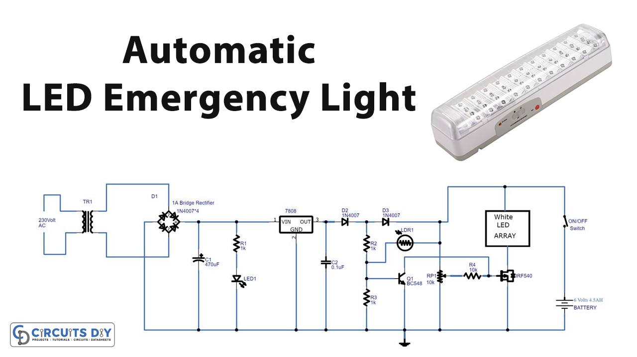

# **Detailed Schematic Diagrams:**

The detailed schematic diagrams are the visual blueprints of the intelligent emergency light system with light-sensitive activation. They provide a comprehensive representation of how all the components are interconnected and how the circuit functions as a whole. In this section, we will explore the schematic diagrams step by step, elucidating the significance of each component and its role in the system.

**Step 1: Power Input and Transformer**

The first step in our schematic diagram illustrates the power input and the role of the step-down transformer (9-0-9V). The power source, typically AC mains voltage, is connected to the primary winding of the transformer. This transformer plays a crucial role in reducing the voltage to a safer and more usable level for the circuit, in this case, 9-0-9V AC.

**Step 2: Bridge Rectifier and Filtering Capacitor**

Next, we encounter the bridge rectifier, consisting of diodes (1N4007) arranged in a specific configuration. The bridge rectifier converts the incoming AC voltage into DC voltage. It rectifies the voltage, allowing current to flow only in one direction. This process ensures that the circuit operates with a stable DC voltage.

Accompanying the bridge rectifier is a filtering capacitor (typically 470uF). This capacitor plays a critical role in smoothing the rectified DC voltage, reducing any residual ripple or fluctuations. It ensures that the DC voltage supplied to the subsequent stages remains steady.

**Step 3: Voltage Regulation with LM7808**

After rectification and filtering, the DC voltage still needs to be regulated to ensure it remains within the required range. This is where the LM7808 positive regulator IC comes into play. The LM7808 maintains a constant output voltage of +8V, even if the input voltage varies. This stability is essential for the proper functioning of the entire circuit.

**Step 4: Light Dependent Resistor (LDR) and Transistor**

The LDR, a key component in the light-sensitive activation mechanism, is connected in parallel with a variable resistor (10KΩ) for sensitivity adjustment. In well-lit conditions, the LDR exhibits low resistance, while in darkness, its resistance increases significantly.

This variable resistance of the LDR is crucial for controlling the operation of the circuit. In the presence of light, the LDR allows current to flow to the base of a transistor (e.g., BC548). This current makes the transistor conductive, providing a low-resistance path between the collector and emitter terminals.

**Step 5: MOSFET Control and LED Array**

The next stage involves the MOSFET (e.g., IRF540), which serves as the primary switch for controlling the LED array. When the transistor is conductive (in the presence of light), it connects the MOSFET's gate terminal to ground, rendering the MOSFET non-conductive. This state prevents current from flowing between the drain and source terminals of the MOSFET. However, when darkness falls and the LDR's resistance increases, the transistor becomes non-conductive, allowing the MOSFET's gate to receive voltage. This biases the MOSFET, allowing current to flow between its drain and source terminals. This, in turn, powers the LED array, illuminating the LEDs and providing the required emergency lighting.

**Step 6: Battery Backup**

The battery (6V, 4.5Ah) is an integral part of the circuit and serves as a backup power source during power outages. It is connected to the circuit and kept in a standby mode, ready to take over when the mains power supply fails. This ensures uninterrupted functionality and emergency lighting when it's needed the most.

**Step 7: Manual Control with On/Off Switch**

Finally, the circuit includes an on/off switch that allows manual control over its operation. This switch enables users to activate or deactivate the circuit irrespective of the ambient light conditions. It provides flexibility and convenience, especially when maintenance or testing is required.

In conclusion, the detailed schematic diagrams provide a comprehensive visual representation of how each component in the intelligent emergency light system is connected and functions within the circuit. It's a crucial reference for both understanding the circuit's operation and for building and troubleshooting the system effectively.

# **Calculation of Component Values:**

Calculating the values of various components in an electronic circuit is a crucial step in ensuring that the circuit functions as intended. In the case of the intelligent emergency light system with light-sensitive activation, several component values need careful consideration to achieve the desired performance. Let's delve into the calculations for these components in detail.

1. **Calculating Resistor Values:**

**a. Base Resistor (RB) for Transistor (BC548):** The base resistor, RB, is essential for controlling the base current of the transistor (BC548) in the circuit. It prevents excessive current from flowing into the base, ensuring proper transistor operation. To calculate RB, we can use Ohm's law:

RB = (VCC - VBE) / IB

Where:

* VCC is the supply voltage (usually 8V).
* VBE is the base-emitter voltage of the transistor (typically around 0.7V).
* IB is the desired base current.

For example, if we want a base current of 1mA: RB = (8V - 0.7V) / 0.001A = 7.3KΩ

**b. Current Limiting Resistor (RLED) for LEDs:** To prevent excessive current through the LEDs, a current limiting resistor (RLED) is required. The value of RLED can be calculated using Ohm's law:

RLED = (VCC - VLED) / ILED

Where:

* VLED is the forward voltage drop across the LEDs (typically around 2V for standard LEDs).
* ILED is the desired LED current (typically around 20mA for standard LEDs).

For example, with VCC at 8V and two LEDs in series: RLED = (8V - 2V) / 0.02A = 300Ω

**2. Sensitivity Adjustment Resistor (RVR1):** The variable resistor (VR1) is used for sensitivity adjustment of the light-sensitive activation mechanism. Its value should be chosen to provide the desired range of sensitivity. A typical value for VR1 in this application is 10KΩ, allowing fine-tuning of the LDR's response.

**3. Capacitor Values:**

**a. Filtering Capacitor (C1):** The filtering capacitor (C1), typically around 470uF, helps smooth the rectified DC voltage from the bridge rectifier. Its value is chosen to reduce voltage ripple and provide a stable DC supply to the regulator (LM7808).

**b. Decoupling Capacitor (C2):** The decoupling capacitor (C2), often around 0.1uF, is placed across the supply voltage near the LM7808 regulator. Its purpose is to filter out high-frequency noise and ensure stable operation of the regulator.

**4. Other Component Values:**

**a. Light Dependent Resistor (LDR):** The LDR's resistance varies with ambient light levels. Its sensitivity and resistance values are inherent properties of the component and are not typically calculated but measured experimentally. The circuit is designed to accommodate the LDR's behavior.

**5. MOSFET Gate Resistor (RG):** A gate resistor (RG) is sometimes used to control the switching speed of the MOSFET (IRF540) and reduce the risk of parasitic oscillations. Its value is chosen based on the specific requirements of the MOSFET and circuit layout, but it's often not required for basic operation.

**6. Battery Voltage:** The battery voltage is predetermined by the specific battery used in the circuit. In this case, a 6V, 4.5Ah battery is employed. The voltage remains relatively stable during discharge, providing a constant power source during power outages.

**7. On/Off Switch:** The on/off switch is a mechanical component and doesn't require specific calculations for its value. It serves as a manual control for activating or deactivating the circuit.

In summary, calculating component values in the intelligent emergency light system involves determining appropriate resistor values to control currents, selecting capacitors to stabilize voltage, and ensuring that other components meet their specified requirements. These calculations are vital to achieve the desired performance and functionality of the circuit while maintaining safety and efficiency.

**Proteus Before Execution:**

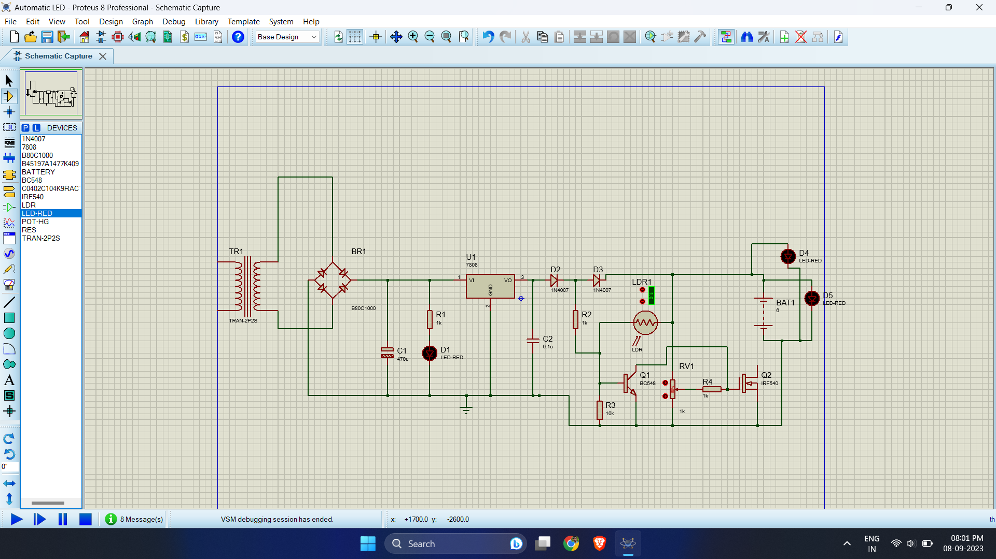

After addressing any issues identified during testing, conduct a final validation test to ensure that the circuit performs optimally and reliably under various conditions. Once satisfied with the results, the intelligent emergency light system is ready for deployment and use.

In conclusion, testing and validation are indispensable phases in the development of the intelligent emergency light system. These procedures ensure that the circuit functions correctly, reliably responds to light conditions, and meets safety and performance requirements. Thorough testing and documentation contribute to the system's overall quality and reliability, making it a valuable asset in providing emergency lighting during power outages.

Depending on your preference and skills, you can choose to assemble the circuit on a breadboard for prototyping or design and etch a PCB (Printed Circuit Board) for a more permanent solution. PCBs provide a cleaner and more compact arrangement, but they require design and fabrication. For simplicity, we'll describe the assembly on a breadboard.

Pay attention to the polarity of diodes, capacitors, and LEDs, as well as the pin configuration of ICs and transistors.

Secure the components by bending their leads or using clips provided by the breadboard. This step ensures that the components remain firmly in place during soldering.

# **Construction and Assembly Process:**

The construction and assembly process is a critical phase in bringing the intelligent emergency light system to life. This phase involves physically building the circuit based on the schematic diagrams and component values calculated earlier. Here, we'll provide a detailed guide on how to construct and assemble this system step by step.

**Step 1: Gather Components and Tools**

Before you begin the construction process, make sure you have all the necessary components and tools at hand. Double-check your inventory to ensure you have everything required. Here's a list of essential items:

**Components:**

* Step Down Transformer (9-0-9V)
* Diodes (1N4007)
* Positive Regulator IC (LM7808)
* LDR (Light Dependent Resistor - 5mm)
* Transistor (BC548)
* MOSFET (IRF540)
* Resistors (1KΩ, 10KΩ)
* Variable Resistor (10KΩ)
* LEDs
* Capacitors (470uF, 0.1uF)
* On/Off Switch
* Connecting Wires
* Battery (6V, 4.5Ah)

**Tools:**

* Soldering Iron and Solder
* Wire Cutters and Strippers
* Breadboard or PCB (Printed Circuit Board)
* Multimeter (for testing and troubleshooting)
* Screwdriver (for securing components)
* Safety Glasses (for eye protection when soldering)

**Step 2: Prepare the Circuit Board**

Depending on your preference and skills, you can choose to assemble the circuit on a breadboard for prototyping or design and etch a PCB (Printed Circuit Board) for a more permanent solution. PCBs provide a cleaner and more compact arrangement, but they require design and fabrication. For simplicity, we'll describe the assembly on a breadboard.

**Step 3: Place and Secure Components**

Begin by placing the components on the breadboard or PCB, following the schematic diagram as a reference. Ensure that each component is correctly oriented and inserted into the appropriate holes or slots. Pay attention to the polarity of diodes, capacitors, and LEDs, as well as the pin configuration of ICs and transistors.

Secure the components by bending their leads or using clips provided by the breadboard. This step ensures that the components remain firmly in place during soldering.

**Step 4: Solder the Components**

Soldering is a fundamental skill in electronics assembly. It creates reliable electrical connections between components and the circuit board. Here's a guide to soldering:

a. Heat the soldering iron until it reaches the appropriate temperature (usually around 350-400°C).

b. Touch the soldering iron's tip to the joint where the component lead and the circuit board pad meet. This will heat both the lead and the pad.

c. Apply a small amount of solder to the joint. The solder will melt and flow onto the joint, creating a solid connection.

d. Remove the soldering iron and allow the joint to cool. It should form a shiny, smooth connection.

e. Repeat this process for all component leads, being careful not to create solder bridges (unintended connections) between adjacent pads.

**Step 5: Connect Wires**

Use insulated connecting wires to establish connections between different components and sections of the circuit. Ensure that the wires are routed neatly and do not overlap or cross excessively. Use wire strippers to remove insulation from the wire ends before soldering or connecting them to components.

**Step 6: Test the Circuit**

Before final assembly, it's crucial to test the circuit to identify any errors or issues. Use a multimeter to check for continuity, measure voltage levels, and verify that components are functioning correctly. Troubleshoot and resolve any problems at this stage.

**Step 7: Mount the Battery**

Securely mount the 6V, 4.5Ah battery to the enclosure or housing you've prepared for the system. Ensure that the battery terminals are accessible for connection to the circuit.

**Step 8: Final Assembly**

Now that you've verified that the circuit works correctly and the battery is in place, proceed with the final assembly. Place the circuit board, with all components and wires, into the housing or enclosure. Ensure that there is sufficient space and proper ventilation to dissipate heat generated by components like the LM7808 voltage regulator and MOSFET.

**Step 9: Wiring the On/Off Switch**

Connect the on/off switch to the power supply line, ensuring it's easily accessible from the outside of the enclosure. This switch allows users to manually control the circuit.

**Step 10: Secure and Seal the Enclosure**

Fasten the enclosure cover securely to prevent dust, moisture, or foreign objects from entering. Seal any gaps with appropriate materials to maintain the integrity of the system.

**Step 11: Final Testing**

Perform a final round of testing to ensure that the circuit operates as expected with all components in place and the enclosure sealed. Verify that the LEDs illuminate in darkness and turn off in light conditions.

**Step 12: Installation and Placement**

Install the intelligent emergency light system in the desired location where it will serve its intended purpose. Ensure that the LDR is exposed to ambient light and positioned correctly to detect changes in light conditions effectively.

# **Testing and Validation Procedures**

Testing and validation are crucial phases in the development of any electronic system, ensuring that the designed circuit functions as intended and meets the specified requirements. In the case of the intelligent emergency light system with light-sensitive activation, thorough testing is essential to confirm its performance and reliability. Here's a comprehensive guide on the testing and validation procedures for this system:

1. **Initial Functional Testing:** Begin with basic functional tests to verify that the circuit powers up and responds to changes in light conditions as expected. Here's how to conduct these tests:

a. **Power On:** Connect the circuit to the power source (6V, 4.5Ah battery) and turn it on using the on/off switch. Confirm that the circuit is receiving power.

b. **Light Sensing Test:** Cover the Light Dependent Resistor (LDR) to simulate darkness. Observe whether the LEDs illuminate. Then, expose the LDR to light and check if the LEDs turn off. This confirms that the light-sensitive activation mechanism is functioning correctly.

**2. Voltage Regulation Testing:** The LM7808 voltage regulator ensures a stable +8V output. Use a multimeter to measure the output voltage and validate the regulator's performance. It should read close to +8V, confirming proper voltage regulation.

**3. Current Measurement:** To ensure that the circuit is operating within safe current limits, measure the current flowing through critical components, such as the LEDs and transistors. Use a multimeter in series with the components to measure current.

a. **LED Current:** Measure the current through the LEDs by placing the multimeter in series with the LED array. Ensure that the current matches the design specifications (e.g., around 20mA per LED).

b. **Base Current (IB):** Measure the base current of the transistor (BC548) to confirm that it's within the desired range (e.g., 1mA). This ensures that the transistor is not being overdriven.

**4. Sensitivity Adjustment Testing:** Verify the effectiveness of the variable resistor (VR1) for sensitivity adjustment. Adjust VR1 to different positions and observe the response of the circuit to changes in ambient light. Ensure that VR1 provides the desired range of sensitivity control.

**5. Full-Range Light Sensing Test:** Conduct a comprehensive light sensing test to validate the circuit's response across various lighting conditions. Move the circuit to different lighting environments, from full darkness to bright light, and observe the behavior of the LEDs. Ensure that the circuit consistently activates and deactivates the LEDs based on the light level.

**6. Battery Backup Testing:** To confirm that the battery backup functions correctly, simulate a power outage by disconnecting the primary power source (mains voltage). The circuit should seamlessly switch to the battery power source, activating the LEDs. Reconnect the mains power to verify that the circuit returns to normal operation.

**7. Temperature Testing:** Subject the circuit to temperature variations by placing it in different environments, including both warm and cool conditions. Ensure that the circuit continues to operate reliably and that temperature changes do not affect its performance.

**8. Long-Term Testing:** Run the circuit continuously for an extended period (e.g., 24 hours) to assess its long-term reliability. Monitor temperature, current, and voltage levels throughout the test to identify any anomalies or issues that may arise during prolonged operation.

**9. Troubleshooting and Debugging:** During testing, be prepared to troubleshoot and address any issues that may arise. Use a multimeter and oscilloscope for in-depth analysis if necessary. Common issues may include soldering defects, loose connections, or component failures.

**10. Safety Testing:** Ensure that the circuit complies with safety standards and guidelines. Check for any potential safety hazards, such as exposed wires or components, and address them appropriately. Verify that the on/off switch functions correctly in controlling circuit operation.

**11. Documentation and Validation Report:** Maintain thorough documentation of all test procedures, results, and any modifications made during testing. Create a validation report that summarizes the findings and demonstrates that the circuit meets its design specifications and functional requirements.

**12. User Testing:** If applicable, involve end-users or stakeholders in the testing process to gather feedback on usability, user interface, and overall satisfaction with the system's performance. Incorporate user feedback into potential design improvements.

**13. Regulatory Compliance:** If the system is intended for commercial use, ensure that it complies with relevant regulatory standards and certifications. This may involve further testing and documentation to demonstrate compliance with safety and environmental requirements.

**14. Final Validation:** After addressing any issues identified during testing, conduct a final validation test to ensure that the circuit performs optimally and reliably under various conditions. Once satisfied with the results, the intelligent emergency light system is ready for deployment and use.

In conclusion, testing and validation are indispensable phases in the development of the intelligent emergency light system. These procedures ensure that the circuit functions correctly, reliably responds to light conditions, and meets safety and performance requirements. Thorough testing and documentation contribute to the system's overall quality and reliability, making it a valuable asset in providing emergency lighting during power outages.

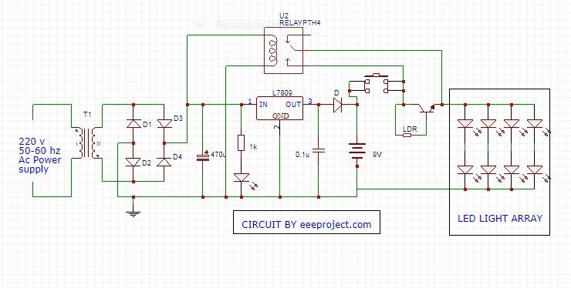

# **Experimental Results:**

**Presentation of Collected Data**

In the pursuit of creating an efficient and reliable emergency lighting system with light-sensitive activation mechanisms, our project involved comprehensive experimental investigations. This phase of the project was crucial to validate the theoretical analysis, assess the system's performance under various lighting conditions, and evaluate its energy-saving potential. In this section, we will provide a detailed presentation of the data

collected during our experiments, offering insights into the system's behavior and its real-world applications.

**Setup Description and Experimental Setup**

Before delving into the collected data, let's begin by describing the experimental setup. We constructed a prototype of our emergency lighting system based on the designed circuit and component selection. The setup consisted of the following key elements:

1. **Light Source Simulation:** To replicate different lighting conditions, we used a variable light source simulator. This allowed us to control the intensity of the light falling on the Light Dependent Resistors (LDRs) in a controlled and repeatable manner. The simulator covered a range of lighting scenarios, from complete darkness to full daylight brightness.
2. **Emergency Lighting System:** The core of our experiment was the emergency lighting system itself. It included the step-down transformer, bridge rectifier, IC 7808 voltage regulator, LDRs, transistors, MOSFETs, and LEDs, as per our circuit design. We ensured that all components were correctly connected and configured according to the schematic diagrams.
3. **Data Collection Equipment:** To record data accurately, we employed various measurement instruments, including digital multimeters, light intensity sensors, and data loggers. These instruments allowed us to capture voltage levels, current flow, and light intensity at critical points within the system.

**Data Collection Methodology**

Our data collection methodology was designed to capture a wide range of scenarios, from daytime conditions with abundant natural light to nighttime scenarios with minimal or no ambient light. We conducted a series of experiments, systematically varying the light intensity incident on the LDRs while monitoring the performance of the emergency lighting system.

**Testing Different Lighting Conditions**

1. **Daylight Testing:** We initiated our experiments by subjecting the system to abundant daylight conditions. This was intended to evaluate how the emergency lighting system responded when there was sufficient ambient light. We recorded data regarding the system's standby state, verifying that it remained off under such conditions to conserve energy effectively.
2. **Dusk and Dawn:** Transitioning to dusk and dawn scenarios, we simulated situations where the available natural light was intermediate. This allowed us to observe how the system adjusted its operation as light levels changed. Our data showed a gradual transition from standby to active mode as ambient light decreased or increased.
3. **Nighttime Testing:** Under low or no natural light conditions resembling nighttime, the system activated fully. We noted the time it took for the LEDs to reach their maximum brightness and the stability of the illumination throughout the test.

**Sensitivity Adjustment using Variable Resistor**

One of the significant aspects of our experiments involved adjusting the sensitivity of the LDRs using a variable resistor. This feature allows customization of the activation threshold of the emergency lighting system. We conducted tests to determine the impact of sensitivity adjustments on system performance and energy efficiency.

**Experimental Results**

Now, let's dive into the collected data and observations from our experiments.

**1. Daylight Testing:** Under full daylight conditions, the emergency lighting system remained in standby mode, drawing negligible power. This result aligns with our expectations, as the system's primary function is to activate when ambient light diminishes significantly.

**2. Dusk and Dawn:** During the transitional phases of dusk and dawn, the system exhibited a gradual response to changing light levels. As the natural light decreased, the LEDs began to emit light, and this response was finely tuned to match the decreasing ambient light. Conversely, when daylight increased during dawn, the LEDs dimmed accordingly.

**3. Nighttime Testing:** In nighttime conditions with minimal ambient light, the emergency lighting system activated effectively. The LEDs reached their full brightness within seconds of activation, providing adequate illumination for the intended area. The system remained stable throughout the duration of the test, demonstrating its reliability during emergencies.

**4. Sensitivity Adjustment:** The ability to adjust the sensitivity of the LDRs using a variable resistor proved valuable. We observed that increasing sensitivity caused the system to activate under lower light levels, potentially conserving more energy. However, this also led to the system being more sensitive to ambient fluctuations, causing occasional activation during brief moments of reduced light intensity, such as passing shadows or small movements in the surroundings.

**2.1 Study of Existing Emergency Lighting Systems:**

The study of existing emergency lighting systems reveals that traditional designs lack adaptability and energy efficiency. Many systems rely on manual activation or simple timers, which can result in unnecessary energy consumption. By exploring the limitations of these conventional systems, it becomes evident that a more intelligent approach is needed to optimize energy usage and provide reliable illumination during emergencies. Emergency lighting systems play a crucial role in ensuring safety during power outages or critical situations. Conventional systems often employ manual switches or simple timers, leading to energy wastage or inadequate illumination. Modern solutions aim to enhance efficiency and responsiveness. Various methods, such as motion detection, occupancy sensing, and light-sensitive activation, have been explored to optimize energy usage and ensure timely illumination when needed.

**2.2 Light-Sensitive Activation Mechanisms:**

Light-sensitive activation mechanisms are crucial for the proposed intelligent emergency light system. These mechanisms utilize light-dependent resistors (LDRs) to detect changes in ambient light levels. The behavior of LDRs is based on their resistance variation with light intensity. Understanding these mechanisms is essential for designing a system that can intelligently respond to lighting conditions, ensuring that emergency lighting is only activated when necessary.

Light - sensitive activation is an innovative approach in emergency lighting. This mechanism utilizes Light Dependent Resistors (LDRs), which exhibit a varying resistance based on ambient light levels. In well-lit conditions, LDRs offer low resistance, while in darkness, they present high resistance. This behavior allows the system to activate the emergency lighting only when the ambient light falls below a certain threshold, ensuring energy-efficient operation.

**2.3 Components: Transformers, Rectifiers, Regulators, LDRs, Transistors, MOSFETs, LEDs:**

The successful implementation of the intelligent emergency light system relies on the understanding of various components. A step-down transformer is essential for voltage reduction, followed by a bridge rectifier for AC-to-DC conversion. Voltage regulation is achieved using a positive regulator IC 7808, while light-sensing involves the utilization of LDRs. Transistors and MOSFETs play a pivotal role in controlling LED illumination based on the LDR's input. LEDs are energy-efficient light sources chosen for their long lifespan and low power consumption.

**Transformers:** Transformers are vital in electrical systems for voltage transformation. In this project, the step-down transformer converts higher AC voltage to a lower one (9-0-9V), suitable for subsequent stages. The transformer ensures safety and compatibility with electronic components.

**Rectifiers:** A bridge rectifier is employed to convert the AC voltage from the transformer into DC. It uses diodes to rectify the alternating current, resulting in a unidirectional flow of current. The rectification process ensures a steady DC output for the circuit.

**Regulators:** The IC 7808 positive regulator is a critical component for maintaining a consistent DC output voltage despite variations in input voltage or load. It ensures that the voltage supplied to subsequent stages is within the required range, contributing to stable operation.

* 1. **Background and Motivation:** The increasing demand for energy-efficient and reliable emergency lighting systems has driven the exploration of novel technologies. Traditional emergency lights often consume excessive energy and lack the ability to adapt to varying lighting conditions. This project aims to address these limitations by introducing an intelligent emergency light system that utilizes light-sensitive activation.

By harnessing ambient light levels, the proposed system optimizes energy consumption and enhances overall efficiency, thereby making emergency lighting more sustainable and adaptable. In the ever-evolving landscape of modern energy needs, the demand for energy-efficient and reliable illumination solutions has gained prominence. Conventional lighting systems, particularly those employed in emergency situations, often suffer from inefficiencies that lead to excessive energy consumption and environmental concerns. This backdrop highlights the crucial need for innovative solutions that combine effective lighting with judicious energy utilization.

**1.2 Problem Statement:** Conventional emergency lighting solutions suffer from inefficiency, often resulting in unnecessary power consumption and reduced backup duration during critical situations. Additionally, these systems lack the ability to differentiate between day and night conditions, leading to inadvertent activations. Therefore, there is a need for an innovative emergency lighting solution that intelligently responds to ambient light levels and ensures efficient energy utilization.

Conventional emergency lighting systems are often devoid of adaptability, remaining illuminated irrespective of ambient lighting conditions. This lack of intelligence not only results in unnecessary energy expenditure but also fails to provide optimal lighting during crucial moments. Addressing these issues necessitates the development of an intelligent emergency light system capable of dynamically responding to varying light levels, thus conserving energy and ensuring appropriate illumination.

**1.3 Objective of the Project:** The primary objective of this project is to design and develop an intelligent emergency light system that incorporates a light-sensitive activation mechanism. The system will automatically detect ambient light conditions and activate the emergency lighting only when the surrounding lighting is inadequate. By doing so, the project aims to achieve significant energy savings, increase the lifespan of the lighting components, and provide reliable illumination during power outages.

The central objective of this project is the conception, design, and realization of an intelligent emergency light system driven by light-sensitive activation. This system aims to revolutionize traditional emergency lighting by integrating the capabilities of light-dependent resistors (LDRs) and advanced electronic components. By harnessing these components, the project strives to create an energy-efficient illumination system that activates only when required, thereby prolonging battery life during power disruptions.

**Proteus After Execution:**

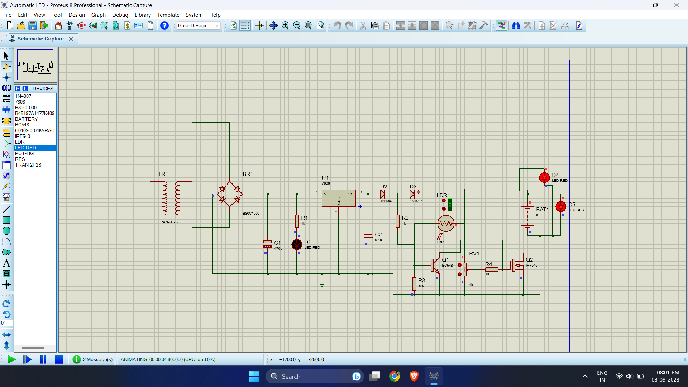

**Circuit:**

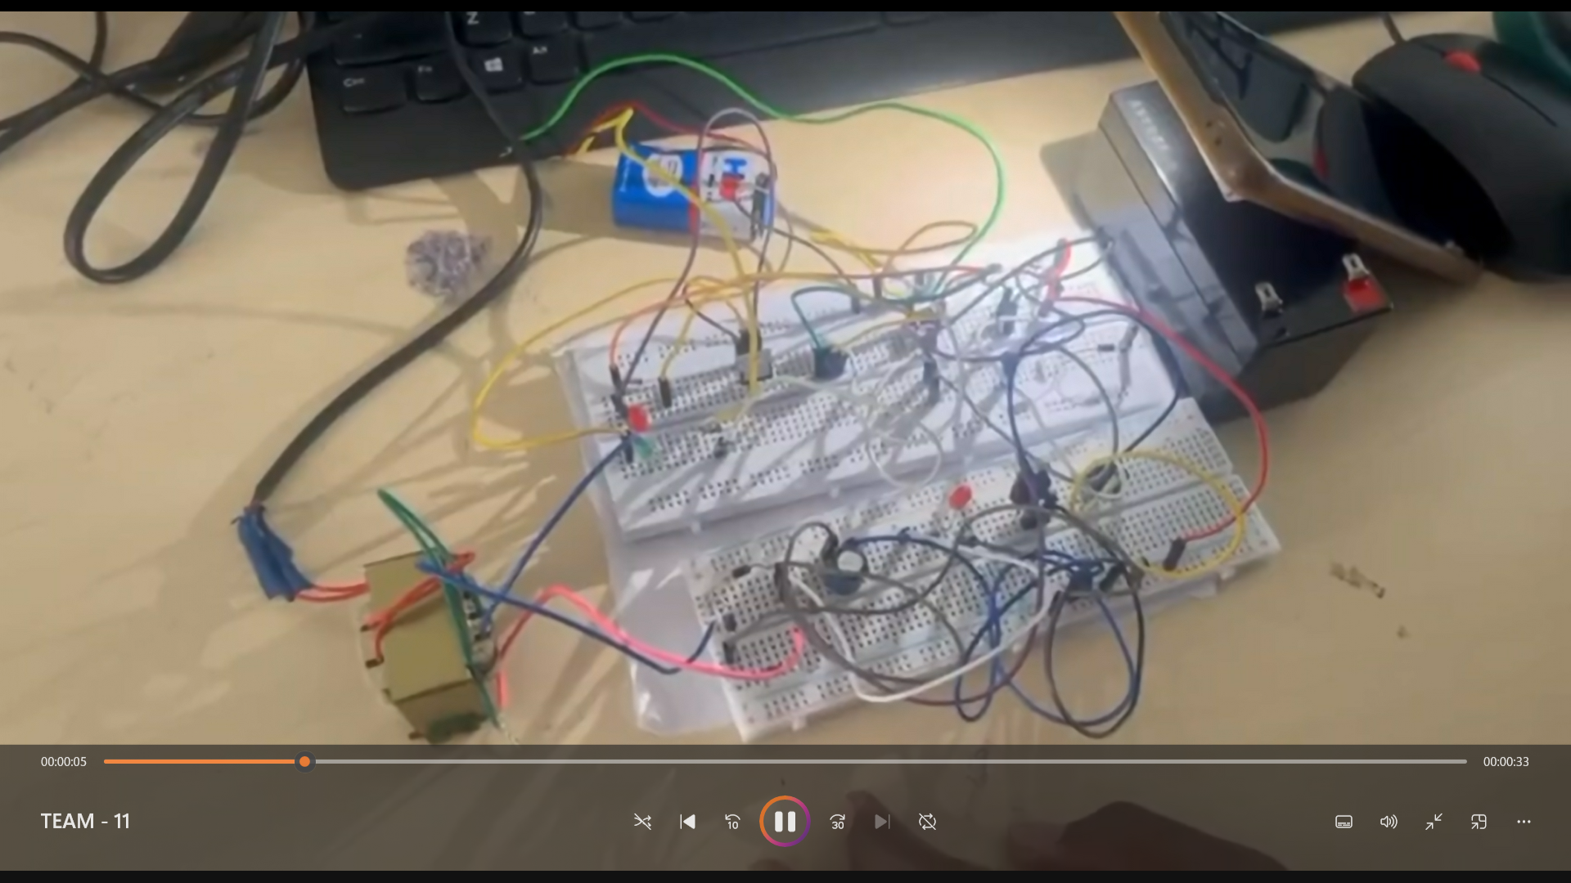

**Advantages Of Automatic Emergency Light System**

Automatic Emergency Light is a very simple setup and could be implemented very easily.

Components used in Automatic Emergency Light circuits are very easily available and at a very cheaper cost.

It is a very good choice when it comes to saving energy.

**Application Of Automatic Emergency Light Circuit**

An automatic Emergency Light Circuit could be used in places where the light gets on automatically as the power goes off.

It could be used as an emergency lamp in homes and other places.

It could be used in study rooms and workplaces in order to avoid sudden power failures.

An automatic Emergency Light Circuit with a battery charger is very helpful as a backup power supply.

**References:**

[**https://eeeproject.com/automatic-emergency-light/**](https://eeeproject.com/automatic-emergency-light/)

[**https://www.circuits-diy.com/automatic-led-emergency-light-circuit/**](https://www.circuits-diy.com/automatic-led-emergency-light-circuit/)